How the Java code is run?
- Lets say you have created one class A (the file name is A.java of course)
- So, when you compile it, one file A.class will be generated. Its just a file that is being stored in the disc.
- After the compilation done, you run that A.class file using java A
  - Now, 2 things will be generated; one object of type Class and one metaspace
  - One variable will be created which will be of type Class ; its nothing but A.class
  - And one metaspace, which will contain all the metadata about the class A like variables, methods, etc etc.
  - That A.class is the reference of that metaspace.
  - In code, we generally perform reflection using A.class so it feels like A.class contains everything; but it is just a reference to that metaspace.
- So, there will be nothing like class A during the run time; JVM creates A.class which is of type Class and it keeps the reference of metaspace which contains all the metadata about the class A.
- NOTE: class keyword is used to create one class; Class is a actual class.
  - 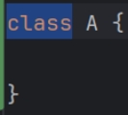 class (lowercase c) is used to define one class
  - 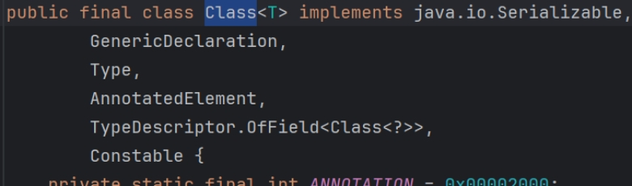
    - It is an actual class which name is Class.
    - This is why it is being said “Class is itself a class, and every class in Java is an object of type Class”
- In case of generic type, it stores the generic information in metaspace.
  - 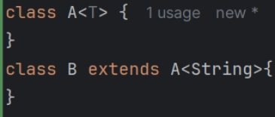
  - You need to pass raw type of type just like the above, I have passed String while inheriting A from B, otherwise how can it know which type is being passed.
  - Because, after the compilation, the generics of objects are gone; the only way to preserve this is inheriting the generic class passing the raw (in my case String) type.
  - ParameterizedTypeReference (abstract class) works in this way; we create an object of a anonymous subclass which inherit ParameterizedTypeReference to keep the generics preserved.
    - It provides some useful methods by default; so instead of creating our own class to preserve the generics, we use this abstract class.
  - 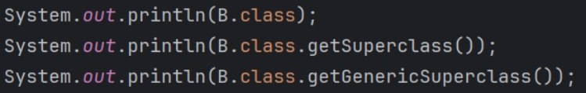
  - 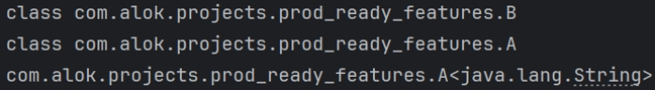
    - output
  - getGenericSuperClass() gives you the super class with generic type; it is of type ParameterizedType
  - getSuperClass() gives you the super class only without generics; it is of type Class.
  - 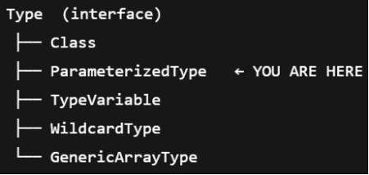
    - Both Class, and ParameterizedType implements Type (which is an interface).
    - So, if you think like the below:
      - 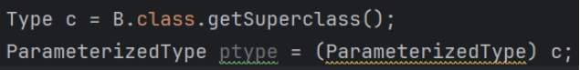
    - It’ll not work; why? Read the next topic about upcasting & downcasting.
    - Both will be true.
  - To see the metaspace of B, execute the command “javap -v B”
    - 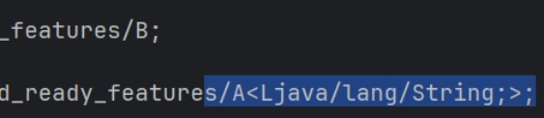
    - You’ll find something like this in the output.

Downcasting during runtime
- Lets say one interface is there named as X and 2 classes A and B are implementing that interface.
  - 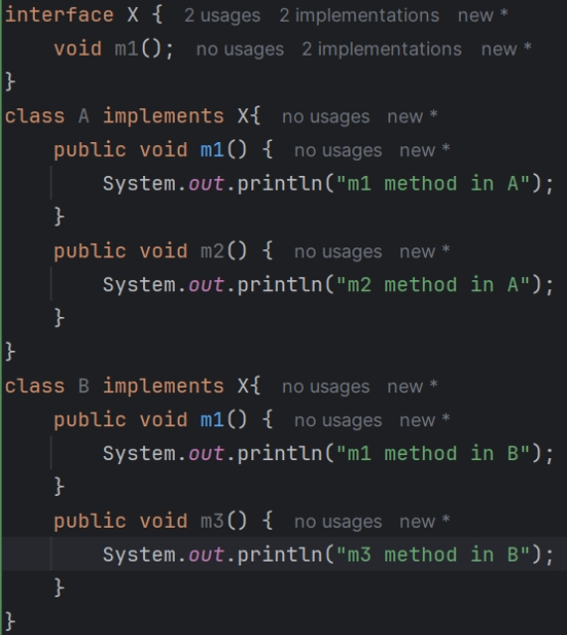
  - A and B are having one extra functions each m2 and m3 respectively.
- Now its obvious, if we create a variable of type X and store the object of type A then we’ll not be able to call the method m2.
  - 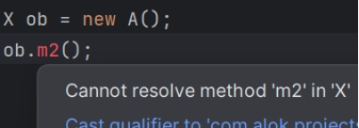
- So there are 2 things, variable type and object type.
  - Lets say one interface or class is there (in our example X)
  - So, the child class may be containing same or more number of methods.
  - So, when we store an object of type child in a variable of type parent, then the variable can ignore the methods that is not in the parent class/interface.
    - 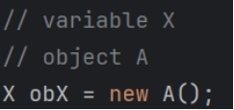
  - But vice versa is not true; if we have a object of type parent and variable of type child, and if we try to store that object to this variable it’ll not be possible;
    - Because, that object (of type parent) might be containing less number of fields and methods than the child.
    - We know, to convert parent type to child type, we have to do downcast; but only if the object type is same as the child.
- Consider the following examples to get a clear picture:
  - 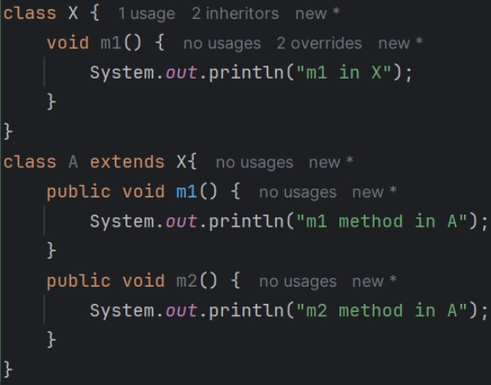
  - 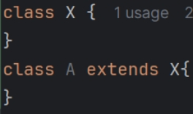
  - This is my classes (parent is X, child is A)
  - 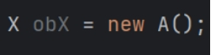
    - It is completely fine; implicitly upcasting is happening here.
    - Object type: A, variable type: X
    - A contains all the fields and methods that is present in X.
    - So, we can access all the things from obX; so there is no error.
  - 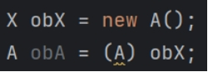
    - It is also same; as we know downcasting has to be mentioned explicitly.
    - Object type: A, variable type: A
    - So, obA can access all the variables of A; so no error.
  - 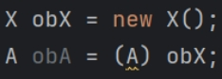
    - It’ll give run-time error; not compile-time.
    - Object type: X, Variable type: A
    - A might be containing more number of methods/fields than X.
    - So, it’ll give run-time error.
- So, there might be a thinking:
  - Lets say A and B are inheriting X.
  - We’ll create one object of type A, and store that in a variable of type X (upcasting).
  - Then we’ll downcast that to B, so now we can convert the A type to B type; it is not possible;
  - 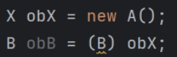❌❌❌❌
  - Because, even if you change the variable type, but the actual object is same only;
- So, upcasting and downcasting is only possible when the object contains all the fields and methods that is being present in the type of which variable is being created.
  - For example, object of type A (let obA) can be stored in variable of type X or A because all the methods and properties of X is there in obA and of course all the things of A will be there in obA .
  - But, B might have some other methods, which A doesn’t have.
So, object of type A cannot be stored in variable of type B.
- In simple terms, upcasting and downcasting is only possible if variable type and object type comes in same hierarchy (A and X are in same hierarchy, but A and B are not).

